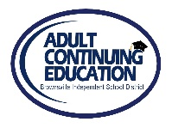 BISD Adult Continuing Education Consortium for Cameron County 
Dr. Jesus H. Chavez Ricardo Rivera
Interim Superintendent Director

ESL Progress Tests 2023-2024

Teacher’s Name: |  | Date Submitted:

TESTER’S Name: _________________________
STUDENTS WITH 60 CONTACT HOURS AM/PM
Baseline Baseline Progress Progress
Form 11
Contact Hours in TEAMS | Student’s Name | TEAMS Participant ID# | BEST Plus Oral  SCORE/ LEVEL |  | Literacy  SCORE/ LEVEL |  | Book | BEST Plus Oral  SCORE/ LEVEL |  | Literacy  SCORE/ LEVEL |  | Book
 | 1.
 | 2.
 | 3.
 | 4.
 | 5.
 | 6.
 | 7.
 | 8.
 | 9.
 | 10.
 | 11.
 | 12.
 | 13.
 | 14.
 | 15.

